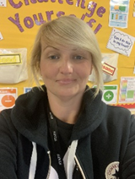
Hi, I’m Mrs O’Donnell😊
I will be your teacher in Year 3/4 and I can’t wait to meet you!

A little bit about me…

  I live with my husband, Denny. I have two children, Fionn who is 9 and Niamh is 5. |   Fionn comes to St Bernadette’s too and he will be going into Year 5 and  Niamh will be going into Year 1 in September. | 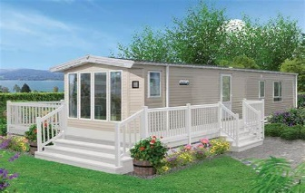  We have a caravan in Wales and we love to go there as often as we can and take the bikes. It is close to a very nice sandy beach too!
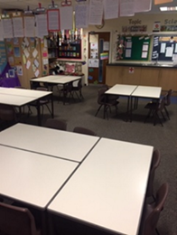 | 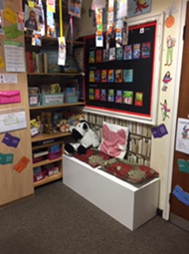 | 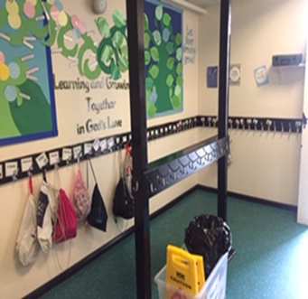
Our classroom where we will do our learning. | Our book area has lots of different books! | Our cloakroom where you will hang your coat and bag in the morning.
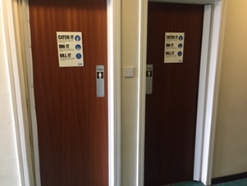 | 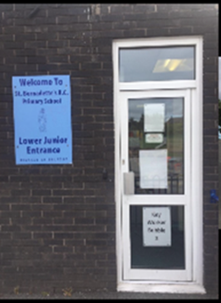 | 
The toilets. | The door where you come in and are picked up. | See you all soon,  Love from Mrs O’Donnell XXXXXX

  My favourite colour is purple. |   My Birthday is in June. |   We go to Ireland a lot to visit family.

