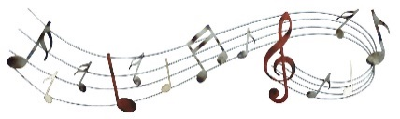 Nursery Curriculum Grid Spring 2 2024

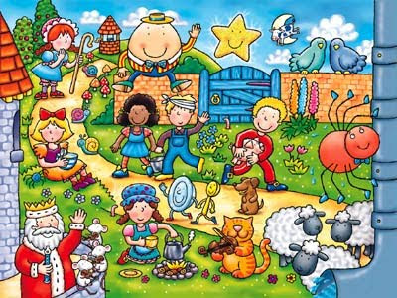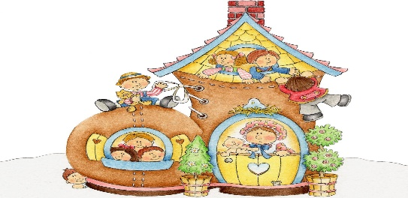

**Important Info and Dates:**

* Book Fair all week – Wk Beginning Monday 4th March
* Book Day Dress Up – Thursday 7th March
* Easter Bonnet Parade – Tuesday 26th March 2.30pm School Hall
* Parents’ evening – Wednesday 27th March -
* Break up – Thursday 28th March at 1.20pm
* Return after Easter break – Monday 15th April

**Who lives in the land of rhyme?**

RE

* Easter Celebrations
* How and why people Gather
* Gathering in Church & Growing in God’s Love
* Lent/ Ash Wednesday – growing to be more like Jesus
* Listening to God’s words

Physical Development

* Cutting skills
* Start taking part in self- initiated group activities.
* Remember sequences of movements with music
* Collaborate with others to move larger items.
* Holding pencil using a “tripod” grip
* Use one handed tools and equipment such as scissors
* Continue to develop different ways of moving

Maths

* Counting 0-5; 0-10
* Understanding position words
* Describe a familiar route
* Make comparisons looking at size/length/weight
* Describe the size and shape of real life objects using vocabulary such as big/small, round, straight.
* Can sort and match according to different criteria

Communication & Language

* Talking about the rhymes and the story in them.
* Sing a large amount of rhymes and songs
* Understanding why questions and answer appropriately.
* To talk about lots of different stories and rhymes from different subjects.
* To use longer sentences and use future and past tense.

Literacy

**Fiction:**

* Nursery Rhyme Books

**Non-Fiction:**

* Recipe Books

**Poetry/Rhymes:**

* Songs and Nursery rhymes

**Phonics:**

* Phase 1 – rhyme, alliteration and initial sounds in words

**Writing:**

* Beginning to write name
* Making letter marks/ marks to give meaning

Understanding the World

* Begin to make sense of own life and their history.
* Show interest in different occupations using Nursery Rhymes they enjoy.
* Explore how things work
* Talk about the differences between materials and changes they notice
* Know that there are different countries in the world and talk about differences

Expressive Arts & Design

* Begin to develop stories in their small world play and role play
* Develop their own ideas how to use materials to design, make and create.
* Draw with more detail
* Explore colour and colour mixing.
* Activities to develop cutting, sticking & joining skills
* Remember entire songs, and match the pitch of others
* Create their own songs

PSED

* Developing sense of responsibility to contribute to classroom routines
* Play with one or more child extending play ideas
* Begin to solve some small conflicts
* Begin to understand the feelings of others and talk about a wider range of feelings