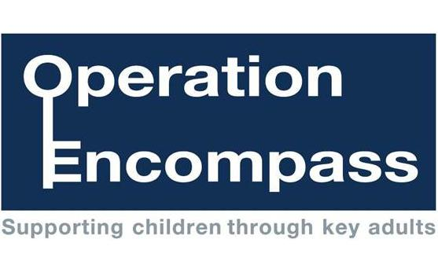

Dear Parent/Carer,

Re: Operation Encompass

Our school has been given the opportunity to take part in a new project that is a Police Initiative and is supported by Bury Safeguarding Board.

The project, Operation Encompass, has been designed to provide early reporting to schools of any domestic abuse incidents that occur outside of school but which might have an impact on a child attending school the following day. This information will be shared on school days during the school term. When incidents occur on a Friday, Saturday or a Sunday, the police will contact the relevant school the following Monday.

A nominated member of school staff, known as a Key Adult, will be trained to liaise with the police. At **St Bernadette’s** our Key Adults are Mr D Proctor and Mrs K Mills. They will be able to use information that has been shared with them, in confidence, to ensure that the school is able to support children and their families. Information will be shared where it is identified that a child or young person was present, witnessed or was involved in a domestic abuse incident.

We always endeavour to offer the best support possible to our pupils and believe that Operation Encompass is going to be beneficial and supportive for all concerned children and families

Full information about Encompass can be found on our school website or you can contact our Key Adult at school.

Thank you for your continued support.

Kind regards,

Mr D Proctor

(Head teacher)

Mrs K Mills

(Deputy Head teacher)

Mrs J Redmond

(Chair of Governors)