Saint Bernadette’s
RC Primary School


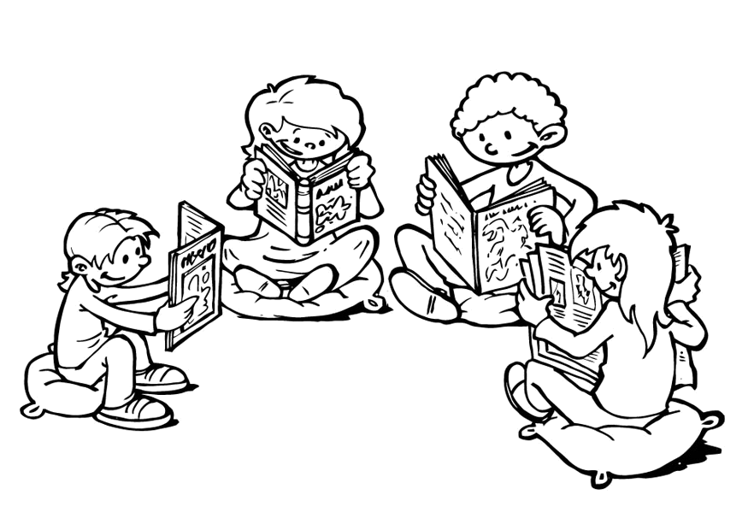

Questioning
For
Reading

Dear Parents

We have put together a series of questions that you could ask your child after they have read their books to you. These are clustered under the different objectives which children in KS1 should be working on. The children often find understanding (particularly inference) most tricky to answer so these might need a bit of extra attention.

I hope these help develop your child’s understanding of the texts they are reading.

Thank you for the support.
The KS1 Team ☺

Develop pleasure in reading, motivation to read, vocabulary and understanding by:

…listening to, discussing and expressing views about a wide range of contemporary and classic poetry, stories and non-fiction texts
What was your favourite part of this book?
Can you find a page in the story/a part of the poem that you didn't like?
Can you choose a character from the story that interests you, and say why?
What made you choose this book? What sort of book is this, and how can you tell?
What is the author's view of this subject/events in this story? How can you tell?

...discussing the sequence of events in books and how information is linked
What is the main event in this story?
What was happening at the beginning of the story?
Can you find words which tell you the order things happened in?
Can you think of another way to begin this story?
Were you surprised by the ending? Is it what you expected?

...becoming increasingly familiar with and retelling a wider range of stories, fairy stories and traditional tales
What happened in the story?
Who do you think is telling this story?
Can you choose part of the story to retell to your friend/group?
How can you use your voice to make your story interesting?

...being introduced to non-fiction books that are structured in different ways
How is this book organised? Does the genre (fiction/non-fiction) affect how the author presents the text?
What is the theme of this book?
Has the author put certain words in bold or in italics? Why do you think they have done this?
Can you find the contents/index/glossary? Why does the author include these?

...recognising simple recurring language in stories and poetry
Can you recognise any patterns in the way words are used in the text?
How do stories often begin? Can you think of a different way to begin this story/section?

...discussing and clarifying word meanings, linking new meaning to those already known
Is this like any other word you know?
Does it sound the same? Does it mean the same?

...discussing their favourite words and phrases
Can you find any amazing adjectives?
Can you find a powerful verb? Why has the author chosen this verb?
Can you find a description of (a character/setting) that you particularly like? Why do you like it?

...continuing to build up a repertoire of poems learnt by heart, reciting some with appropriate intonation to make meaning clear
Can you join in and remember this poem?
How can you use your voice to make the meaning clear? Can you use volume and change your voice to help?

understand both the books they read accurately and fluently and those they listen to by:

...drawing on what they already know or on background information and vocabulary provided by the teacher
What do you already know about this topic?
Have you ever been in a similar situation? What happened? How did you feel/behave?

...checking that the text makes sense to them as they read, and correcting mistakes
Did that make sense? Can you work out what this (unfamiliar) word means by reading the words around it?
How does punctuation help you to read for sense?

..making inferences on the basis of what is being said and done
Why did (a character) behave in this way?
Can you choose a character from the story that interests you and say why?
How does the character feel at this point in the story? Can you find clues in the text and illustrations to show me why you think this?

...predicting what might happen on the basis of what has been read so far
Based on the cover/this chapter/section, what do you think the book/next section will be about?
Using role play, can you act out what you think might happen?

