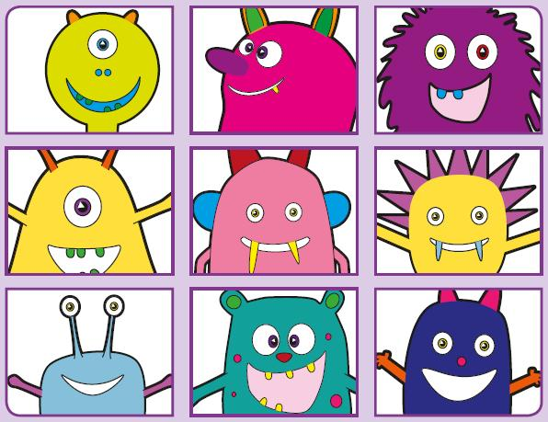
Phonics Screening Practice

In this pack are the split vowel digraphs
u-e* o-e *makes a ‘ew’ and ‘you’ sound and the alternative sounds for i and o (for alien words either pronunciation is accepted)




shobe
quole
gope
soge
pole
mole
stole
hole
chule
pute
grule
phune
dispute
flute
tube
cube
thrin
slig
plind
drim
blind
remind
behind
grind
jop
stog
stok
quolt
so
go
cold
golden

