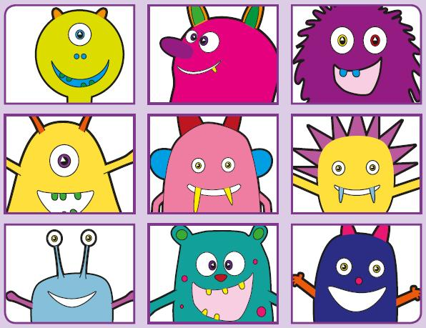Phonics Screening Practice

In this pack are the split vowel digraphs

**u-e\* o-e** \*makes a ‘ew’ and ‘you’ sound and the alternative sounds for i and o (for alien words either pronunciation is accepted)



shobe

quole

gope

soge

pole

mole

stole

hole



chule

pute

grule

phune

dispute

flute

tube

cube



thrin

slig

plind

drim

blind

remind

behind

grind



jop

stog

stok

quolt

so

go

cold

golden