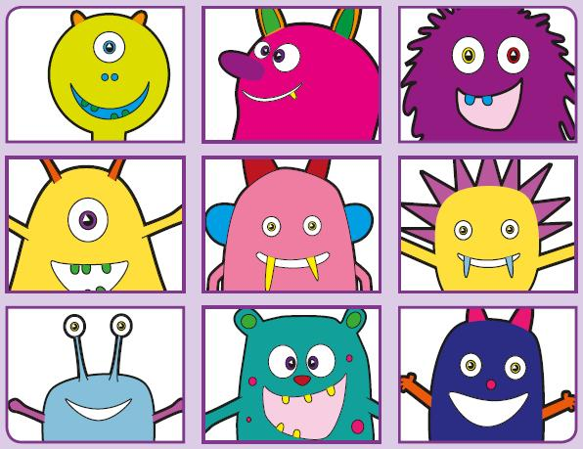Phonics Screening Practice

In this pack are the digraphs

**ow\*, ur, oo\*\* and or**

**\*as in grow and cow**

**\*\*as in zoo or look**

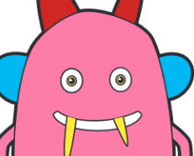

rowf

quow

plowck

frowt

frown

growl

window

blow



thurl

curph

sturck

surb

Thursday

turn

purse

church



quoock

sproot

proock

groob

smoothie

wood

book

roof



mork

forp

sporg

korch

torch

thorn

north

fork