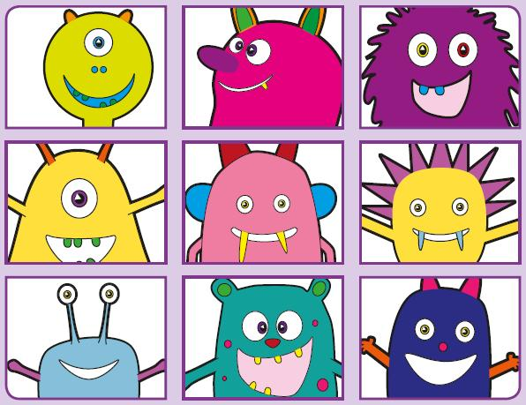
Phonics Screening Practice

In this pack are the digraphs
ow*, ur, oo** and or
*as in grow and cow
**as in zoo or look
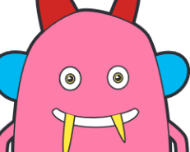



rowf
quow
plowck
frowt
frown
growl
window
blow
thurl
curph
sturck
surb
Thursday
turn
purse
church
quoock
sproot
proock
groob
smoothie
wood
book
roof
mork
forp
sporg
korch
torch
thorn
north
fork

