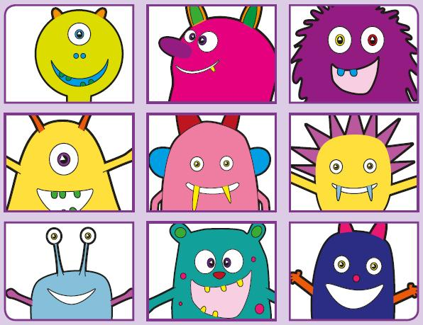Phonics Screening Practice

In this pack are the digraphs **ai, er, oa and ou**



smail

quaib

maif

paick

rail

sprain

stain

paint



sperg

merll

sterk

perng

sister

letter

warmer

finger



thoab

sproav

roath

foang

foam

throat

goal

cloak



douth

snouv

croup

flouff

mountain

shout

round

trousers