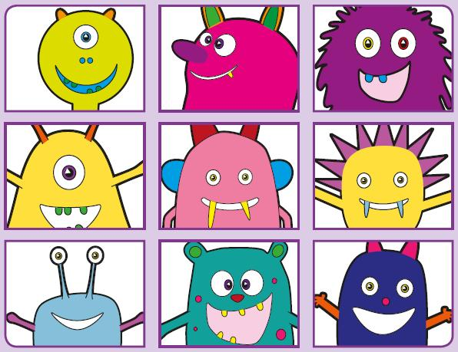
Phonics Screening Practice

In this pack are the digraphs ai, er, oa and ou
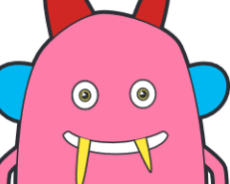



smail
quaib
maif
paick
rail
sprain
stain
paint
sperg
merll
sterk
perng
sister
letter
warmer
finger
thoab
sproav
roath
foang
foam
throat
goal
cloak
douth
snouv
croup
flouff
mountain
shout
round
trousers

