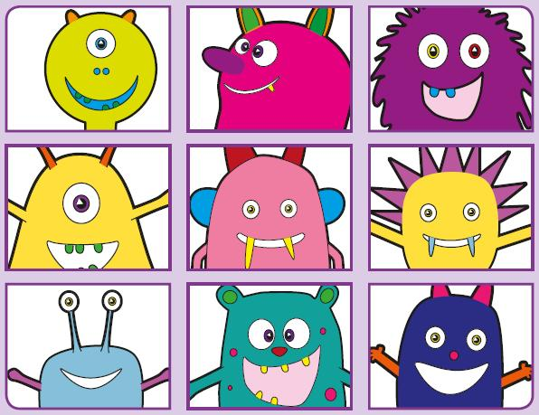
Phonics Screening Practice

In this pack are the trigraphs air ure igh ear




zair
jair
gair
bair
pair
stairs
fair
hair
ture
vure
zure
fure
pleasure
treasure
sure
pure
dright
strigh
prigh
spight
tight
night
sight
flight
flear
zear
splear
brear
gear
year
fear
hearing

