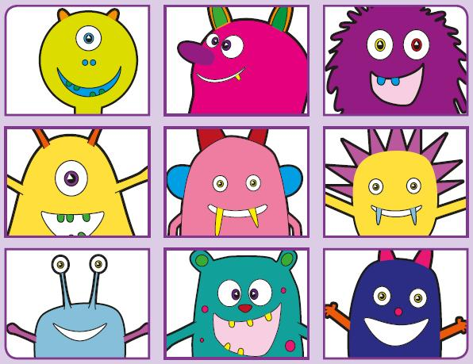Phonics Screening Practice

In this pack are the trigraphs **air ure igh ear**



zair

jair

gair

bair

pair

stairs

fair

hair



ture

vure

zure

fure

pleasure

treasure

sure

pure



dright

strigh

prigh

spight

tight

night

sight

flight



flear

zear

splear

brear

gear

year

fear

hearing