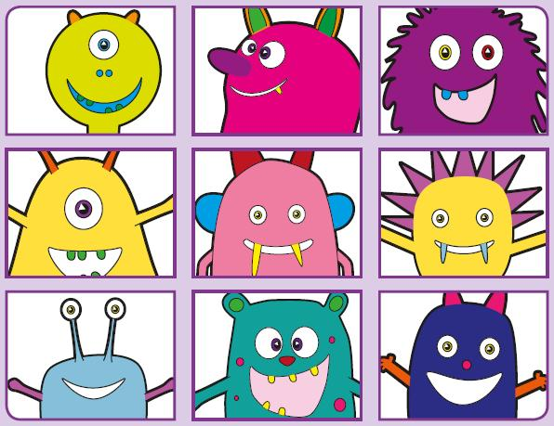
Phonics Screening Practice

In this pack are the digraph and split vowel digraphs
ew* a-e e-e i-e
*makes a ‘yoo’ and ‘ew’ sound




rew
srew
sprew
cew
stew
pew
screw
grew
chale
brate
grale
phane
lake
grate
mistake
cake
compslete
slene
prene
splete
Pete
extreme
compete
Steve
mije
fipe
sline
quile
beehive
strive
spine
hike

