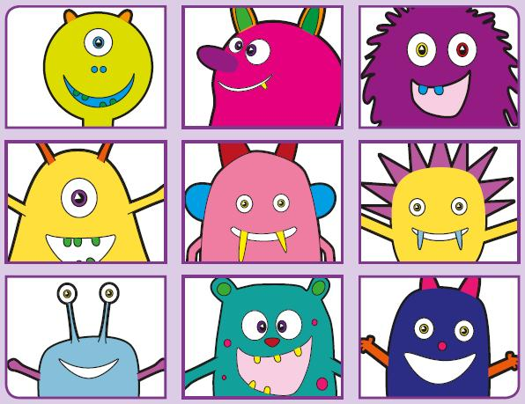Phonics Screening Practice

In this pack are the digraph and split vowel digraphs

**ew\* a-e e-e i-e**

\*makes a ‘yoo’ and ‘ew’ sound



rew

srew

sprew

cew

stew

pew

screw

grew



chale

brate

grale

phane

lake

grate

mistake

cake



compslete

slene

prene

splete

Pete

extreme

compete

Steve



mije

fipe

sline

quile

beehive

strive

spine

hike