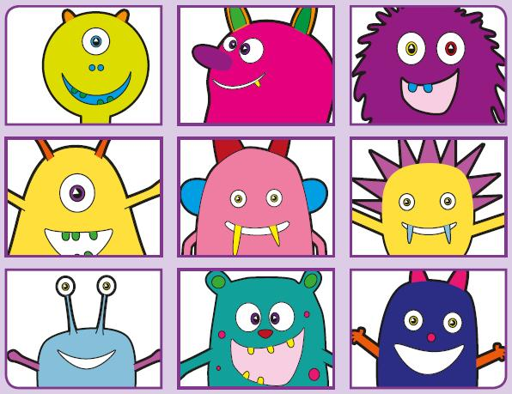Phonics Screening Practice

In this pack are the digraphs **wh* ph oe au**

* **Makes a ‘w’ or a ‘h’ sound depending on the word**



whan

whoin

whep

whoy

whip

whole

whisper

wheel



phirb

pheab

phay

phoim

graph

phonics

dolphin

elephant



quoe

spoe

proe

sploe

dominoes

goes

Joe

toe



mauk

faup

spaul

paut

pause

sauce

autumn

haunted