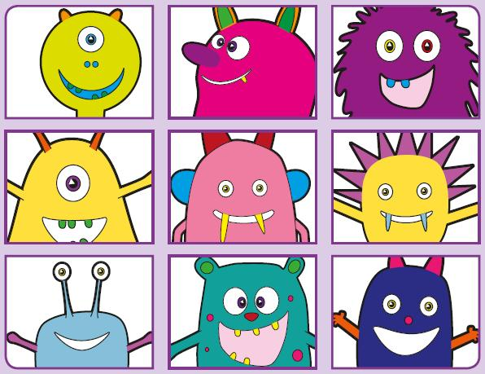
Phonics Screening Practice

In this pack are the digraphs wh* ph oe au
- Makes a ‘w’ or a ‘h’ sound depending on the word




whan
whoin
whep
whoy
whip
whole
whisper
wheel
phirb
pheab
phay
phoim
graph
phonics
dolphin
elephant
quoe
spoe
proe
sploe
dominoes
goes
Joe
toe
mauk
faup
spaul
paut
pause
sauce
autumn
haunted

