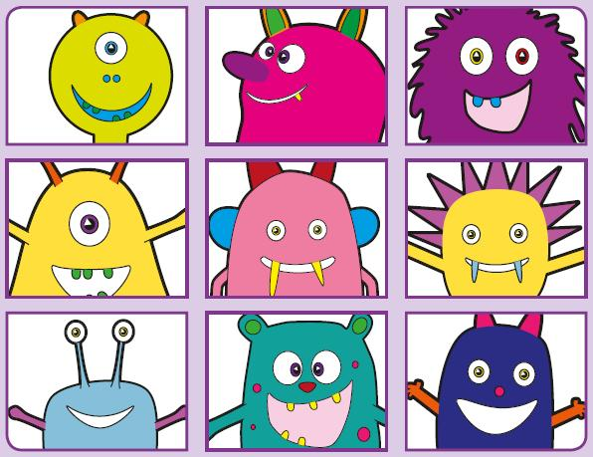
Phonics Screening Practice

In this pack are the digraphs oy ir ue aw
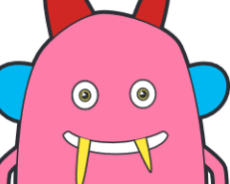
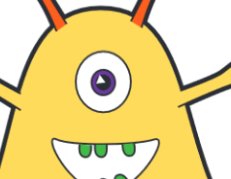
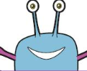
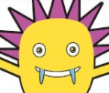
twoy
spoy
groy
broy
employ
annoying
annoy
boy
pirb
blirm
sirl
splird
squirt
twirl
thirteen
bird
gue
bue
prue
splue
statue
fuel
blueberry
barbeque
zaw
faw
spaw
quaw
flawless
drawing
awful
hawk

