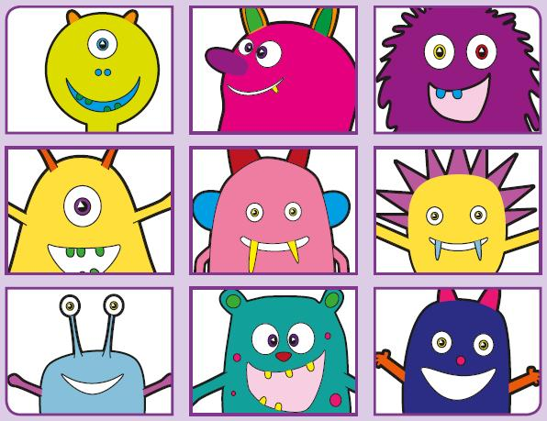Phonics Screening Practice

In this pack are the digraphs **oy ir ue aw**

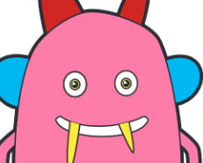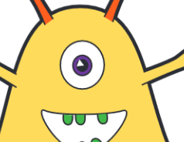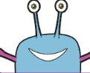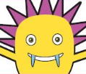

twoy

spoy

groy

broy

employ

annoying

annoy

boy



pirb

blirm

sirl

splird

squirt

twirl

thirteen

bird



gue

bue

prue

splue

statue

fuel

blueberry

barbeque



zaw

faw

spaw

quaw

flawless

drawing

awful

hawk