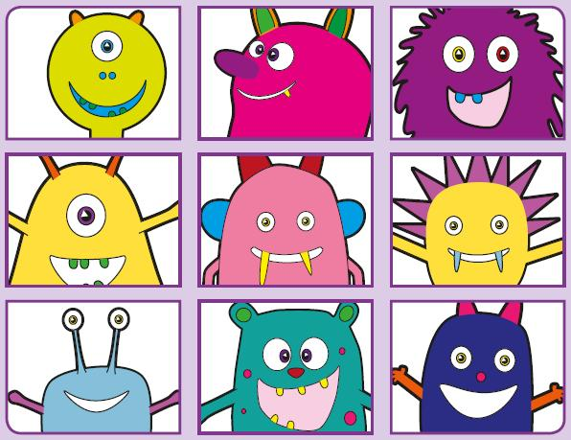
Phonics Screening Practice

In this pack are the digraphs ay ou ie ea
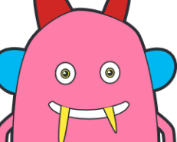



treap
speal
gream
pleam
dream
stream
team
beads
quie
blie
strie
splie
lie
pie
die
tie
yount
spoug
proun
splouk
mountain
counting
proud
cloud
scray
sday
rolay
puay
birthday
holiday
clay
play

