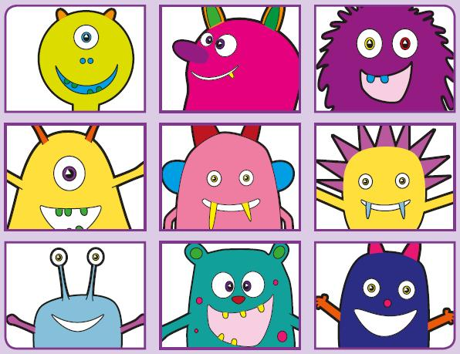Phonics Screening Practice

In this pack are the digraphs **ay ou ie ea**



treap

speal

gream

pleam

dream

stream

team

beads



quie

blie

strie

splie

lie

pie

die

tie



yount

spoug

proun

splouk

mountain

counting

proud

cloud



scray

sday

rolay

puay

birthday

holiday

clay

play