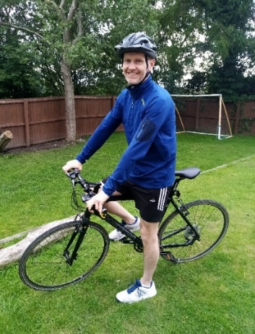

Hi, I’m Mr Davies!!! 😊

I will be your teacher in Year 5 and I can’t wait to meet you!

|  |
| --- |
| A little bit about me… |

|  |  |  |
| --- | --- | --- |
| I live with my wife and 2 sons - Joshua and Leo. My wife is French and comes from the  city of  Nantes. | I like going to restaurants, doing sports and reading. My favourite films are Avatar and The Jungle Book.  I support  Bolton. | Eiffel Tower - WikipediaI like to go to  France for  holidays to  visit my wife’s  family. I once  went up to the  top of the Eiffel  Tower. |

|  |  |  |
| --- | --- | --- |
| My favourite colour is blue.  Shades of blue - Wikipedia | My Birthday is in September.  Chocolate buttercream with Oreos and cigarillos (quick cakes) – The Cake  Shop | I enjoy  reading and  gardening.  In Summer,  I grow my  own plants. |

|  |
| --- |
| Have a look at our classroom… |

|  |  |  |
| --- | --- | --- |
| **Year 5** | **Our cloakroom** | **Our classroom entrance** |
| **Our toilets** | **The exit**  **door**  **to the KS2**  **playground.** | **Looking forward to**  **seeing you** |